*Florida International University*

*School of Computing and Information Sciences*

CIS 4911 - Senior Capstone Project

Software Engineering Focus

Feature Document

User Story # 538

**Team Member:**

Garrett Lemieux

**Product Owner(s)**:

Francisco Ortega

**Mentor(s)**:

Francisco Ortega

**Instructor**: Masoud Sadjadi

**User Story – Change Line Size**

* As a User I would like to change the starting width of a line to be drawn in order to allow for user to draw varying line sizes.
* **Acceptance Criteria**:

1. User must be able to change the size of the line before he or she draws line.

**Use Case: User changes Line Size**

User wants to be able to change the width or size of the line before he or she draws on canvas.

* Details:
* Actor:
  + User
* Pre-conditions:
  + Acer Multi touch device must be connected.
  + TouchPoints app is running.
* Description:
  + Use case begins when User has decided to change the size or width of the line he or she would draw on canvas.
  + User can press ‘z’ to decrease size of drawn line.
  + User can press ‘x’ to increase the size of drawn line.
  + Use case ends once the user finishes drawing a line on canvas and the line is either increased or decreased depending on user’s selection.
* Post-conditions:
  + The size or width of the line has decreased if ‘z’ key was selected.
  + The size or width of the line has increased if ‘x’ key was selected.
* Alternative Courses of Action:
  + User can decrease the size of line painted by pressing ‘z’ key.
  + User can increase the size of line painted by pressing ‘x’ key.
* Decision Support:
  + Frequency: High, User will need to be able to draw varied sized lines in order to make diverse pictures.
  + Criticality: High, Allows Users to create unique pictures.
  + Risk: High, Developer had to learn how libcinder worked in order to implement varied width for lines.
* Usability:
  + User need to be able understand and follow user guide.
* Reliability
  + High
* Performance
  + Performance High
  + Failure Low
* Supportability
  + Multi-touch Screen (ACER)
* Modification History:
  + Owner: Garrett Lemieux
  + Initiation Date 01/30/2016
  + Date last Modified: 04/27/2016

**Use Case Diagram**

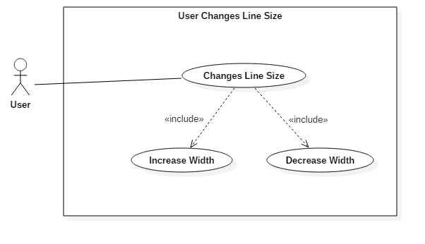

**Sequence Diagram**

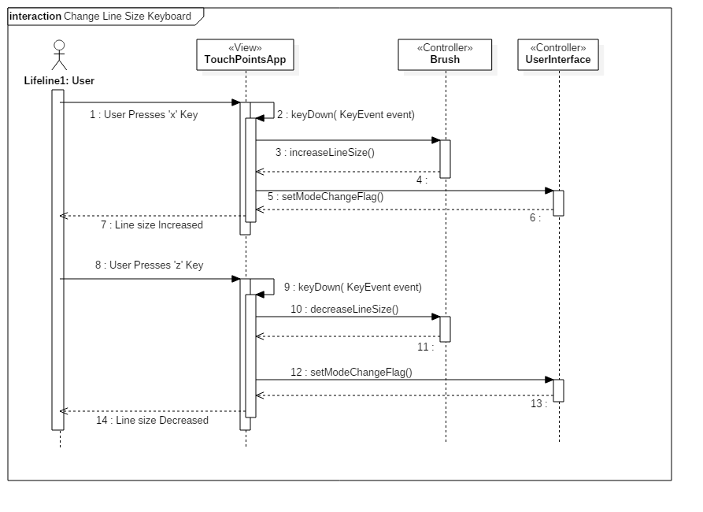

**Class Diagram**

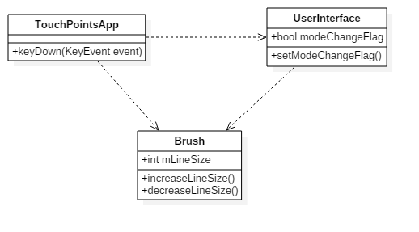

**Unit Test**

* Sunny Day Test:
  + Test Case  - User Presses ‘x’ Key
    - Test Purpose: To determine if user can increase the width of the line to be drawn by pressing ‘x’ key.
    - Test Procedure: User plugs in Acer Multi touch device and starts program. He or she then draws one line. User presses ‘x’ button once and draws a second line. Presses ‘x’ key a third time and draw a third line.
    - Expected Results: User should see that line two is thicker then line one and line three should be thicker than line two.
  + Test Case  - User Presses ‘z’ Key
    - Test Purpose: To determine if user can decrease the width of the line to be drawn by pressing ‘z’ key.
    - Test Procedure: User plugs in Acer Multi touch device and starts program. He or she then presses ‘x’ key three times and draws one line. User presses ‘z’ button once and draws a second line. Presses ‘z’ key a third time and draw a third line.
    - Expected Results: User should see that line two is thinner then line one and line three should be thinner than line two.
* Rainy Day Test:
  + Test Case  - User accidently Presses Increase Key
    - Test Purpose: To determine if user can go back and forth between increasing and decreasing line width.
    - Test Procedure: User plugs in Acer Multi touch device and starts program. He or she draws one line. He or she then presses ‘x’ when he or she really wanted to decrease size of line. He or she draws a second line. Once users realizes mistake he or she presses ‘z’ key and draws a third line.
    - Expected Results: First line drawn should be the default line size. The user should see that the second line is thicker than the first even though the opposite result was desired. The user should then see a third line that is the same size as the first.

**Integration Testing**

* The User has the ability to change the width of the line at any point while using the program.
* The width can be toggled back and forth by pressing ‘z’ and ‘x’ key.
* If user presses the key passed the set max size the program still runs correctly.
* The lines width attribute is only affected when ‘z’ and ‘x’ keys are pressed.

**User Guide**

* Devices Used: Acer Multitouch

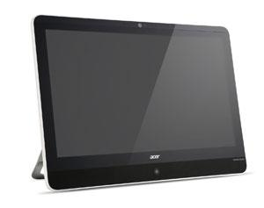

* In order for user to decrease the line size or width, he or she must press the ‘z’ key before the line is drawn.
* In order for user to increase the line size or width, he or she must press the ‘x’ key before the line is drawn.
* If user starts program and draws a line with default size. Then presses ‘x’ key once and draw a second line and presses ‘x’ a second time and draws a third line, he or she should expect to see the following results.
* If user then presses ‘z’ key once and draw a fourth line and presses ‘z’ a second time and draws a fifth line, he or she should expect to see to the following results.

**Glossary**

* N/A